**MOVIE TICKET BILLING**

**PPS PROJECT**

Aryan Thapliyal – RA2111011010001

Khyat Ramani – RA2111011010004

Kshitij Garge – RA2111011010006

Krishnan Nandkumar – RA2111011010025

**INDEX**

|  |  |
| --- | --- |
| Sl. No | Title |
| 1 | About the project |
| 2 | Source code |
| 3 | Screenshots of execution |
| 4 | Scope of the Project |
|  |  |

**ABOUT THE PROJECT**

Movie Ticket Billing System is based on the concept of booking movie tickets. There’s no login system available for this system, the user can freely use its feature. This mini project contains limited features, but the essential one.

Talking about the features of this system, the user can book movie tickets. For this, the user has to select a movie name, enter customer details such as name and phone number. Then the user has to enter seat number. After this, the booking is done. The user can also change the ticket price and view reservations by entering the admin password. The last feature of this project is about cancelling the tickets which can be done by entering the booking id.

The system does not create an external file to store the user’s data permanently. This system is in C Programming Language and different variables, strings have been used for the development of it.

**LOGIN CREDENTIALS**

Username – “user”

Password – “pass”

**SOURCE CODE**

#include<stdio.h>

#include<stdlib.h>

#include"Bookingdetails.c" // This is an externally attached file.

#include"decleration.c" // This is an externally attached file.

#include<strings.h>

struct Bookingdetails person[300];

int count=0;

int id2=1000;

int main()

{

int **seat,choice,price,selection;

seat=(int **)calloc(101,sizeof(int *));

int a=0,i=0;

char uname[10],c=' ';

char pword[10],code[10];

char user[10]="user";

char pass[10]="pass";

do

{

printf("\n ######################## LOGIN PAGE ######################## "); //This is a Password protected application.

printf(" \n\n ENTER USERNAME:-");

scanf("%s", &uname);

printf(" \n\n ENTER PASSWORD:-");

scanf("%s",&pword);

printf("\n\n ##############################################################");

if(strcmp(uname,"user")==0 && strcmp(pword,"pass")==0)

{

printf(" \n\n\n WELCOME TO OUR BOOKING SYSTEM !!!! LOGIN IS SUCCESSFUL");

printf("\n\n\n\t\t\t\tPress any key to continue...");

break;

}

else

{

printf("\n SORRY !!!! LOGIN IS UNSUCCESSFULL");

a++;

}

}

while(a<=2);

if (a>2)

{

printf("\nSorry you have entered the wrong username and password for three times!!!");

exit(0);

}

system("cls");

for (i=0;i<3;i++)

*(seat+i)=(int *)calloc(101,sizeof(int ));

int x;

while(x!=5)

{

choice=choice1();

switch(choice)

{

case 1:

details();

break;

case 2:

selection=movie();

reservation(seat[selection-1],price,selection);

count++;

break;

case 3:

selection=cmovie();

cancel(seat[selection-1]);

break;

case 4:

x=5;

break;

default:

printf("Choice not available\n");

break;

}

}

}

void reservation(int *array,int price,int selection)

{

int i,j;

printf("\n SCREEN\n\n\n");

for (i=1;i<=100;i++)

{

if (array[i]==0)

printf("%d\t",i);

else

printf("*\t",i);

if(i%10==0)

printf("\n\n");

}

printf("Please enter your name: "); // The program asks us about our details.

scanf(" %19[^\n]%*[^\n]",&person[count].name);

printf("Please enter your phone number: ");

scanf("%u",&person[count].phone);

printf("Which seat number you want? ");

scanf("%d",&j);

if(j<=40)

{

price=300 ;

}

else if(j>40&&j<=80)

{

price=400;

}

else if(j>80&&j<=100)

{

price=450;

}

else

{

printf("Invalid seat number\n");

}

if (j>100||j<1)

{

printf("Seat number is unavailable in this theater\n");

printf("Please re-enter seat number: ");

scanf("%d",&j);

}

if (array[j]==1)

{

printf("Sorry, this ticket is already booked! Please choose another seat.\n");

scanf("%d",&j);

}

else

array[j]=1;

person[count].seat=j;

if (selection==1)

ticket1(j,person[count].name,id2,price);

else if (selection==2)

ticket2(j,person[count].name,id2,price);

else

ticket3(j,person[count].name,id2,price);

id2++;

}

int choice1(void)

{

int choice;

printf(" Movie Ticket Billing System\n"); //This is the Main interface page of our application.

printf(" ==================================================================\n");

printf(" ==================================================================\n");

printf("|| 1- To view reserved tickets (only admin): ||\n");

printf("|| 2- To purchase ticket: ||\n");

printf("|| 3- To cancel the seat: ||\n");

printf("|| 4- Exit system: ||\n");

printf("||================================================================||\n");

printf(" ==================================================================\n");

printf(" Enter your choice: ");

scanf("%d",&choice);

return choice;

}

void cancel(int *array)

{

int Cseat,i,stop;

printf("Please enter ID number of ticket: ");

scanf("%d",&Cseat);

for (i=0;i<300;i++)

{

if(Cseat==person[i].id)

{

stop=5;

system("cls");

printf("%s your seat is %d cancelled",person[i].name,person[i].seat);

array[person[i].seat]=0;

i=300;

}

}

if (stop!=5)

printf("Ticket ID number is incorrect please enter right one to cancel ticket: \n");

}

void ticket1(int choice,char name[10],int id2,int price) // This is the Movie Ticket

{

system("cls");

printf("\n\n");

printf("\t-----------------MOVIE TICKET----------------\n");

printf("\t============================================================\n");

printf("\t Booking ID : %d \t\t\tShow Name : American Pie\n",id2);

printf("\t Customer : %s\n",name);

printf("\t\t\t Date : 29-04-2019\n");

printf("\t Time : 08:00pm\n");

printf("\t Hall : 02\n");

printf("\t seats No. : %d \n",choice);

printf("\t price . : %d \n\n",price);

person[count].id=id2;

printf("\t============================================================\n");

return;

}

void details(void)

{

int i;

char pass[10],pak[10]="pass";

printf("Enter the password to see details: ");

scanf("%s",&pass);

if (strcmp(pass,pak)==0)

{

for (i=0;i<count;i++)

{

printf("seat no: %d is booked by %s booking id is %d\n",person[i].seat,person[i].name,person[i].id);

}

}

else

printf("Entered password is wrong \n");

system("PAUSE");

system("CLS");

}

int movie(void)

{

int i;

system("cls");

printf("\t\t\twhich movie you want to see?\n");

printf("\t\t\t----------------------------\n\n");

printf("\t\t\tpress 1 for American Pie\n\n");

printf("\t\t\tpress 2 for 365 Days\n\n");

printf("\t\t\tpress 3 for Spider-Man: No Way Home\n");

scanf("%d",&i);

system("cls");

return i;

}

void ticket2(int choice,char name[10],int id2,int price)

{

system("cls");

printf("\n\n"); //This is the Movie Ticket.

printf("\t-----------------MOVIE TICKET----------------\n");

printf("\t============================================================\n");

printf("\t Booking ID : %d \t\t\tShow Name : 365 Days\n",id2);

printf("\t Customer : %s\n",name);

printf("\t\t\t Date : 15-04-2019\n");

printf("\t Time : 09:00pm\n");

printf("\t Hall : 03\n");

printf("\t seats No. : %d \n",choice);

printf("\t price . : %d \n\n",price);

person[count].id=id2;

printf("\t============================================================\n");

return;

}

int cmovie(void)

{

int i;

printf("\t\t\twhich movie ticket you want to cancel\n");

printf("\t\t\t-------------------------------------\n");

printf("\t\t\tpress 1 for American Pie\n\n");

printf("\t\t\tpress 2 for 365 Days\n\n");

printf("\t\t\tpress 3 for Spider-Man\n");

scanf("%d",&i);

return i;

}

void ticket3(int choice,char name[10],int id2,int price)

{

system("cls"); //This is the Movie Ticket.

printf("\n\n");

printf("\t-----------------MOVIE TICKET----------------\n");

printf("\t============================================================\n");

printf("\t Booking ID : %d \t\t\tShow Name : Spider-Man: No Way Home \n",id2);

printf("\t Customer : %s\n",name);

printf("\t\t\t Date : 5-07-2019\n");

printf("\t Time : 10:00pm\n");

printf("\t Hall : 04\n");

printf("\t seats No. : %d \n",choice);

printf("\t price . : %d \n\n",price);

person[count].id=id2;

printf("\t============================================================\n");

return;

}

**SCREENSHOTS OF EXECUTION**

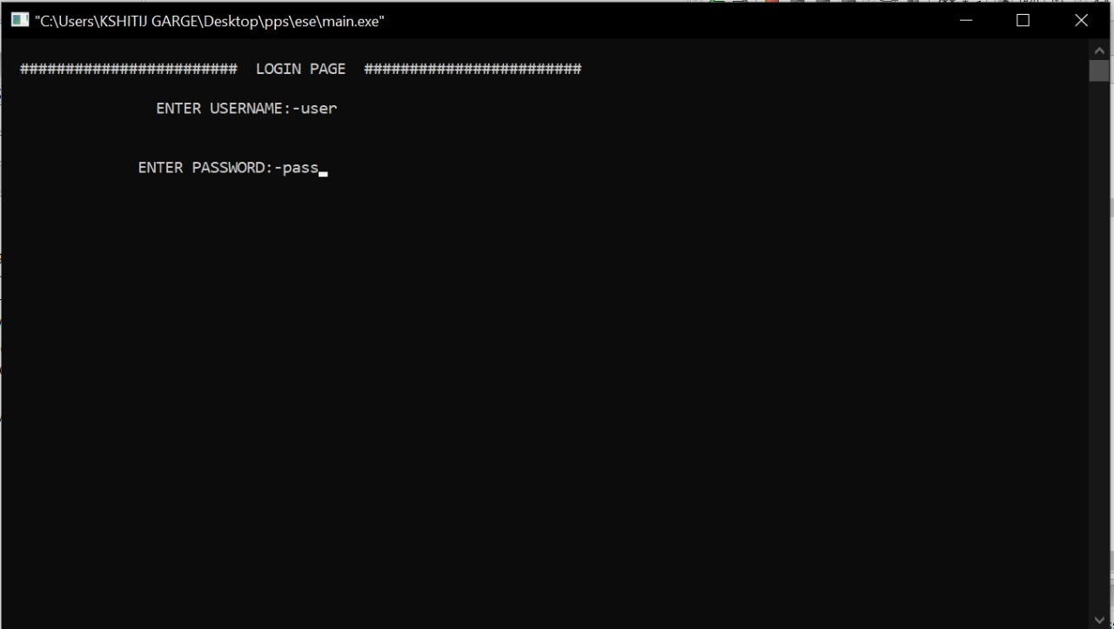

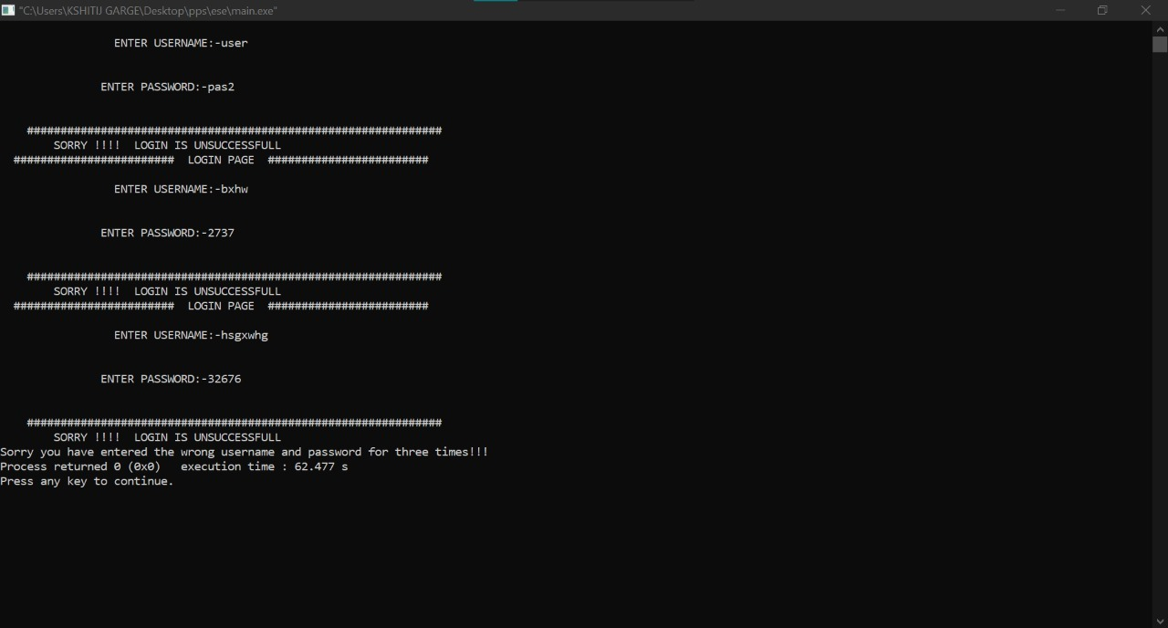

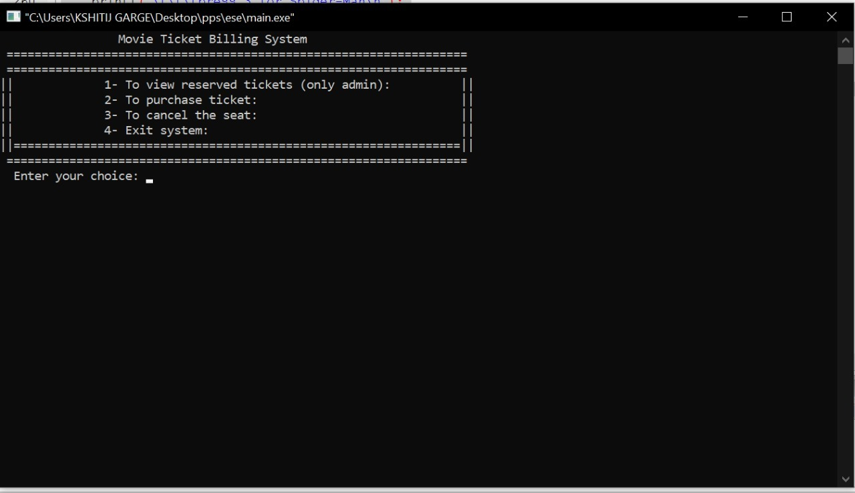

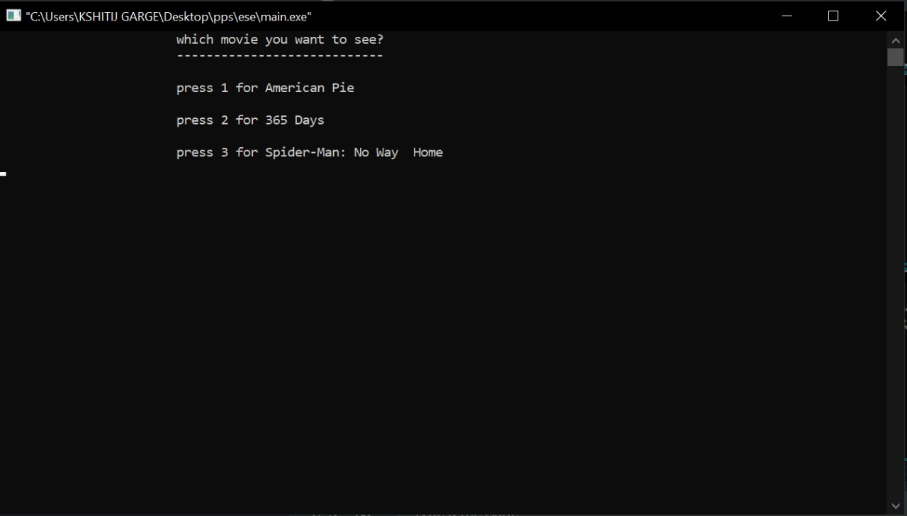

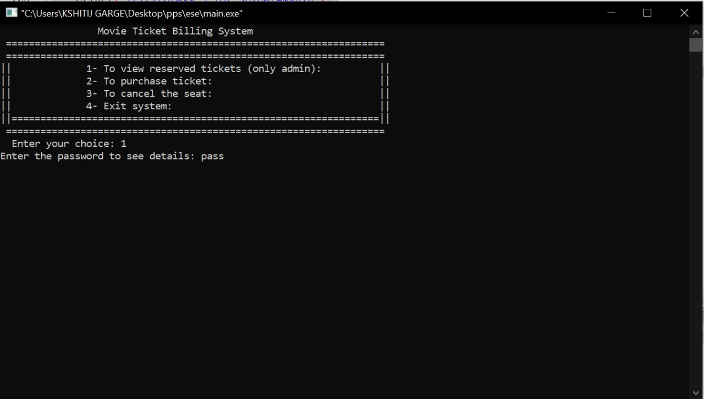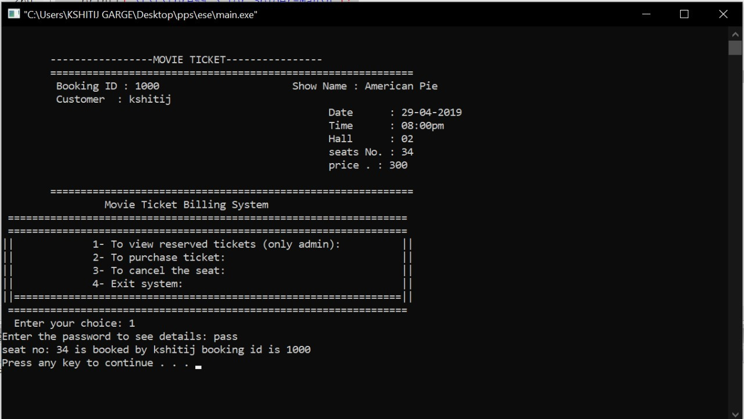

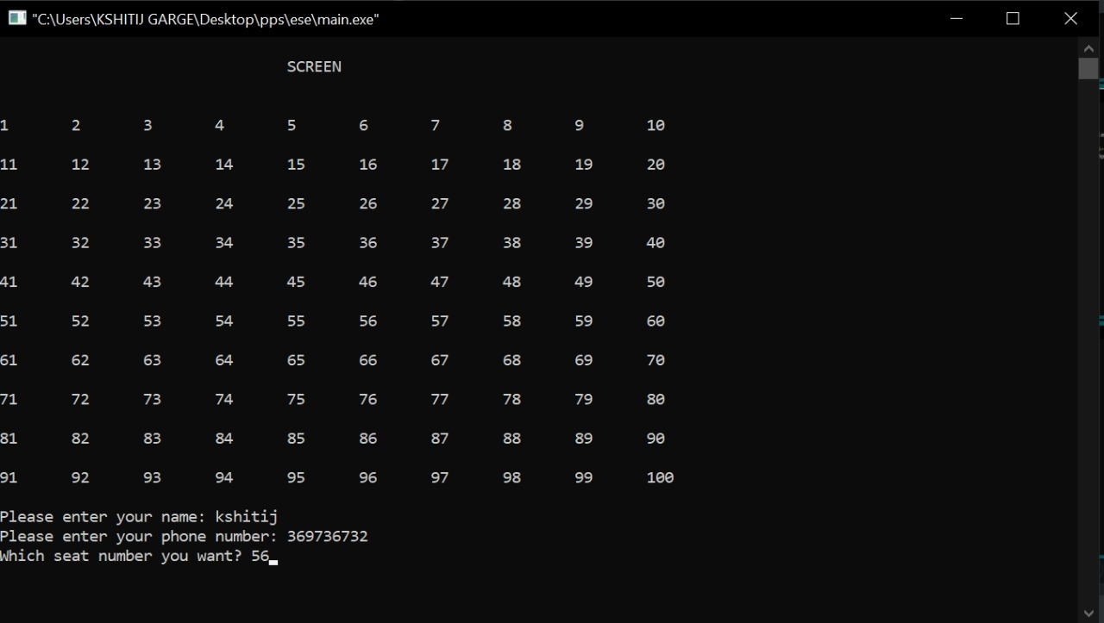

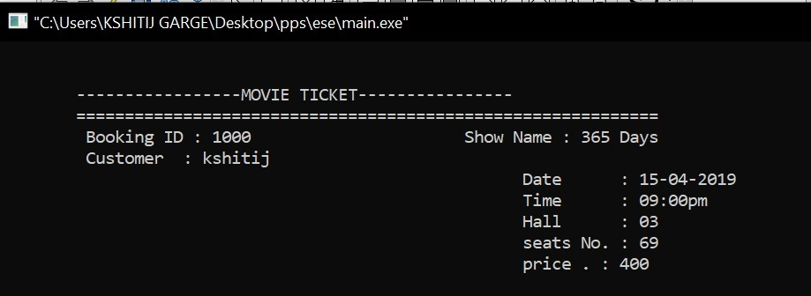

**SCOPE OF THE PROGRAM**

In this program you can perform functions such as choosing movies, selecting seats as per your preference, cancellation of seats, Also different seats have variable prices.so the project can definitely guide you to understand c mini project in a better way.

Here, you can perform functions such as add books, return books, issue books, delete record of books issued, view record of books issued, search for books, and more. File handling has been extensively used in this project for almost all functions. So, this project can definitely guide you to understand C mini projects in a better way.

The source code is organized well, and it has multiple comment lines to help you understand the project better.